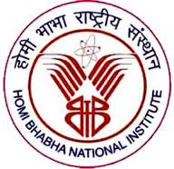
Homi Bhabha National Institute

Ph. D. PROGRAMME
ORAL GENERAL COMPREHENSIVE EXAMINATION REPORT
(OGCE)

- Name of the Student :
- Name of the Constituent Institute : Institute of Physics
- Enrolment No, :
- Board of Studies : PHYSICAL SCIENCES

The Oral General Comprehensive Examination of Shri / Ms. ______________________ was conducted on _____________ . The mentoring / doctoral committee is fully satisfied with his / her performance and permits him / her to continue with his / her Ph.D. programme.

Mentoring / Doctoral Committee :

S.No. | Name of Doctoral Committee | Designation | Signature | Date
1. |  | Chairman
2. |  | Convener
3. |  | Member
4. |  | Member
5. |  | Member
6. |  | Member

