Fast atoms Diffraction at surfaces
H. Winter
Humboldt-Universität zu Berlin, Newtonstr. 15, 12489 Berlin, Germany

Scattering and interaction phenomena of fast (keV) atoms or molecules with matter are generally discussed in terms of classical mechanics. The main argument for neglecting quantum mechanical effects here, compared to thermal atom scattering, is an extremely small Broglie wavelength λ_{dB} compared to the length scale for ordered structures at crystal surfaces. Furthermore, one expects for fast atoms substantial decoherence owing to excitations of projectile and target, since scattering is accompanied with energy dissipation (electronic and nuclear stopping).

Recent work, however, shows that the observation of diffraction with fast atomic projectiles is possible for grazing scattering from insulator surfaces [1,2]. For scattering along low indexed strings of atoms in the surface plane we observe peak structures in the angular distributions which are assigned to different diffraction orders. The suppression of excitations during scattering from insulator targets due to their broad band gap results in reduced energy loss and straggling and thus in less decoherence. Nevertheless we found that the appearance of diffraction during grazing scattering of keV projectiles is not restricted to insulator surfaces only.

We will demonstrate that diffraction of fast projectiles is a general principle. Even for metal surfaces, reconstructed surfaces and surfaces with adsorbed atoms forming superstructures we observe well-defined diffraction patterns. As an example we show in the upper panel of Figure 1 an 2D intensity distribution for scattering of 0.6keV H₂ with a grazing angle of incidence of Φ_{in}=1.0 deg along a <1-10> direction of a Fe(110) surface with 1/3 monolayer sulphur coverage forming a c(1x3) superstructure. Pronounced peak structures are observable on a circle of radius Φ_{in}. The intensity inside the annulus projected onto the azimuthal exit angle is shown in the lower panel. Beside the zero order diffraction peak (without azimuthal deflection) further equally separated peaks up to 8th order are detected. The distance of adjacent peaks is determined by λ_{dB} and the periodicity length of the structure only. We will demonstrate that this can be used as a tool to determine lattice constants and superstructures.

Furthermore the intensity of the diffraction peaks is affected by quantum mechanical diffraction in terms of supernumerary rainbows [3], which have their origin in interference caused by the corrugation of the interaction potential. This feature for diffraction can be observed up to projectile energies of 20 keV despite considerable excitations of surface and projectile.
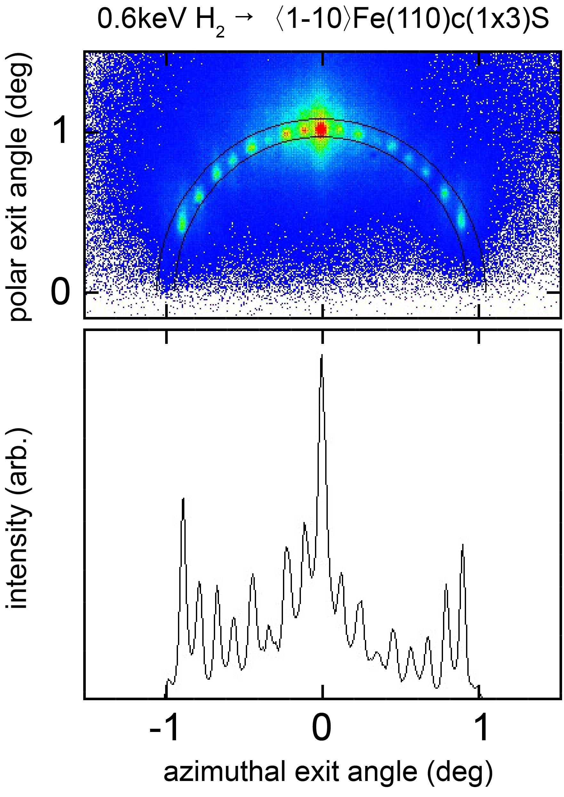
Figure 1: Upper panel: 2D intensity distribution for scattering of 0.6keV H₂ molecules with grazing angle of incidence Φ_{in}=1.0 deg along a <1-10> direction of a Fe(110) surface with 1/3 monolayer S forming a c(1x3) superstructure. Lower panel: projection of intensity inside annulus onto azimuthal exit angle.

- A. Schüller, S. Wethekam, and H. Winter, Phys. Rev. Lett. 98, 016103 (2007).
- P. Rousseau, H. Khemliche, A. G. Borisov, and P. J. Roncin, Phys. Rev. Lett. 98, 016104 (2007).
- A. Schüller, and H. Winter, Phys. Rev. Lett. 100, 097602 (2008).

